Adding a Canon Printer (Windows 10)

Click here if you'd like to view a video of the process (https://youtu.be/jWDiztTP01o).

- Make sure your Active Directory user account has been elevated to be a local administrator for the Windows 10 computer on which you're adding a printer. If you are not yet a local administrator, you will need the assistance of someone in the technology department to elevate your account. Please enter a ManageEngine ticket, then complete the steps in this document before returning here to add a printer.
- Find the Canon printer(s) you would like to use on this spreadsheet: https://goo.gl/ReSF5N. You will need the information from that/those line(s) to add and configure the printer(s).
- In your browser, visit this link: https://goo.gl/FfNRRb then click SELECT on the most up-to-date recommended Generic_Plus_UFRII driver.
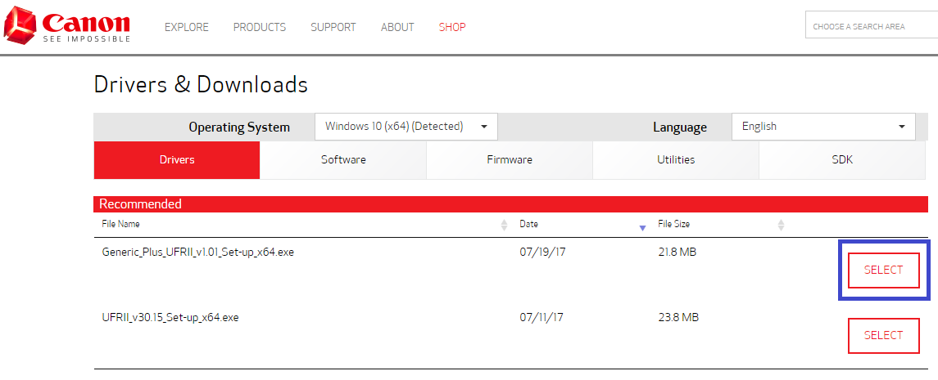
- Click on the DOWNLOAD icon, and if asked, keep the file
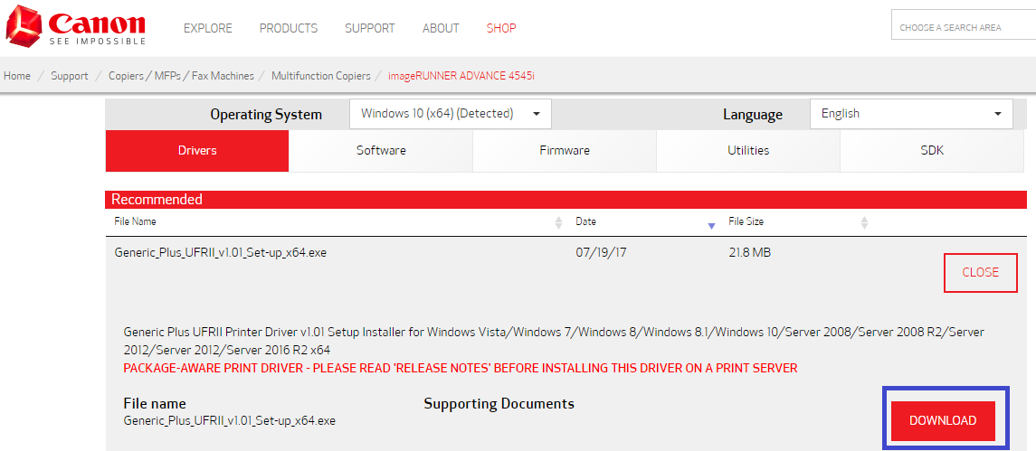
- Click the self-extracting archive file to extract it in your Downloads folder
- Click on the folder icon in the Windows taskbar, then Downloads, then the Generic_Plus_UFRII driver folder, then the Setup Application
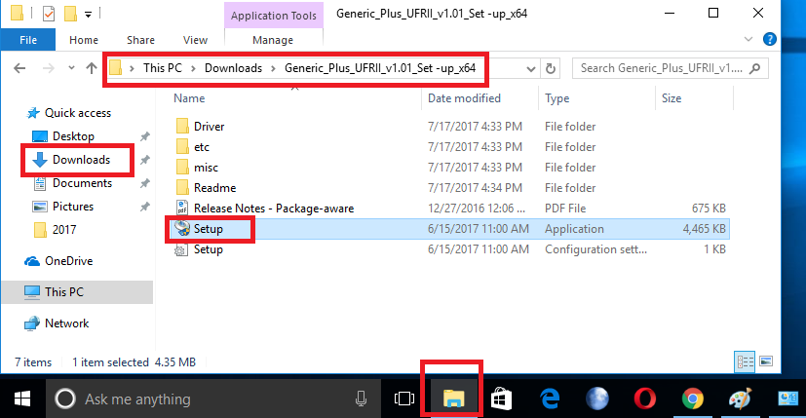
- Follow the first few driver installation prompts, most likely Next >, Yes, then choose the Custom radio button, then make sure the Canon Driver Information Assist Service box is checked, then Next >, Next >.
- At the Printer Information prompt, click Add Port… and Standard TCP/IP Port, then OK.
- Follow the first few installation prompts, most likely Next >, and type in the IP address (column H from this spreadsheet) for your printer of choice, and click Next >, then Finish. This should bring you back to the driver installation prompts.
- In the driver installation prompts, Click Next >, Start, and let it install the printer driver.
- When the installation finishes, make sure the box next to Restart My Computer Now is unchecked, then click Exit.
- Back in the Devices and Printers Control Panel window, right click on the new Canon printer (probably called Canon Generic Plus UFR II), and choose Printer properties.
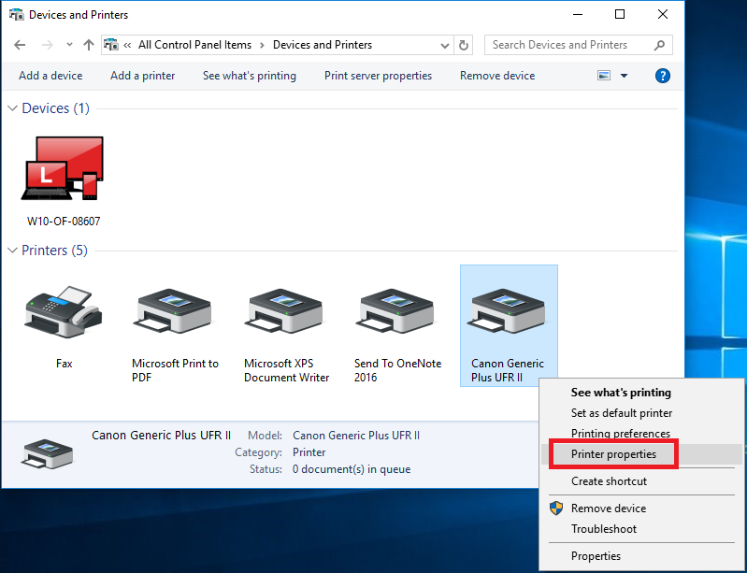
- Under the General tab, rename the printer as something that you will be able to recognizes (suggested name is the Network Name in the spreadsheet (column N)), and click OK.
- In the Devices and Printers Control Panel window, right click on the new Canon printer, and choose Set as default printer.
This file is available at https://goo.gl/KDjFfa

